NEWS RELEASE
CONTACT:
Megan Shen
marketing@blingyte.com

Blingy Launch New Beauty Application: Reauty
Reauty leads as an industry gamechanger to empower beauty seekers.

SAN FRANCISCO, CA. -- 10:00 AM PST, March 24th, 2022 -- Today, The Blingy Technology & Entertainment, Inc. (aka Blingy) breaks through the conventional rules of the beauty industry with the beta version of an innovative beauty rating application - Reauty. "Reauty was born out of the need to speak out against the status quo of the industry and address the beauty stakeholders' pain points, including the beauty seekers, micro-influencers, and beauty brands," said Joy Yuan, Founder & CEO of Blingy.

Leveraging its scientifically based product analysis and easy-to-navigate ingredient safety scores, Reauty shed light on the lack of transparency and regulations in the beauty sector, diving deep into thousands of products to protect users from choosing unsafe, risky ingredients. Reauty’s product analysis function covers all products for beauty needs, such as cosmetics, hair, skin, nails, lips, and men's care. Users will be able to navigate through their preferences for product attributes and discover clean, vegan, sustainable, and cruelty-free tagged products at ease.

With deep machine learning algorithms and the support of its strong database, Reauty acts as an information aggregator that serves as a beauty “kayak” to give effective solutions for

user’s skin types and concerns within seconds. The database-powered search also empowers users with a personalized experience. Reauty features an AI chatbot, Baebee, to give each user a
customized quiz that breaks down their skin types, targeted skin concerns, and preferences for products and ingredient tags, which aids Reauty's smart search engine to generate bespoke top results. This feature paired with the barcode scanning system turns finding the best matches and top-rated products into a productive journey.

Personalization is taken a step further with the AI Skin Analysis feature. Reauty's advanced AI engine has been trained on millions of face and skin images. It can swiftly and accurately evaluate the facial skin of users of various skin tones and identify over 10 essential skin health and beauty benchmarks. With image recognition technology, this one-of-a-kind AI analyzes facial skin problems and proposes personalized solutions, beauty tips, and product recommendations to customers.
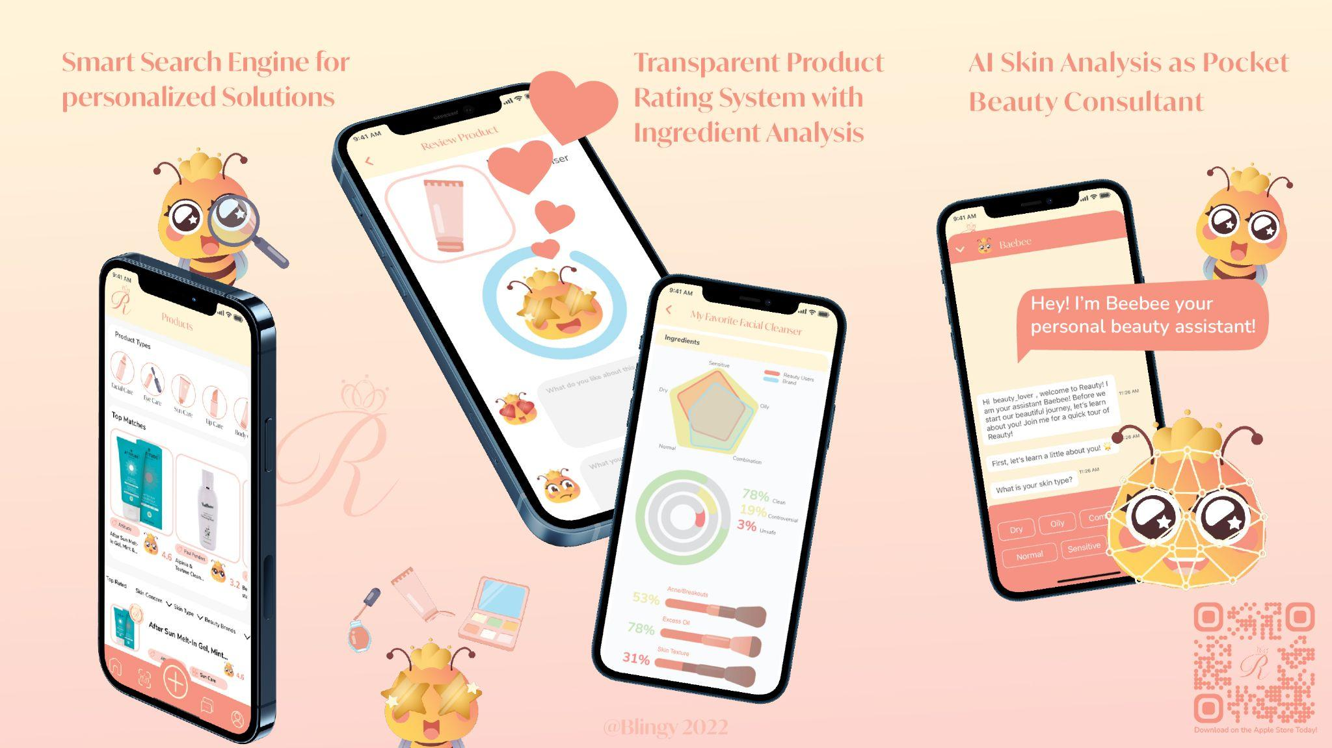
(more)

Reauty's purpose emphasizes transparency to empower beauty lovers.
P. 2
In addition to the three main features, Reauty fosters an authentic community that supports inclusivity. Users can easily find their preferred women-owned, BIPOC owned, and sustainable or inclusive brands. Reauty also features a transparent rating system that provides users with a genuine product score from 100% user-generated reviews. It brings together all beauty lovers with similar needs and concerns to express their honest views and experiences as consumers while helping and inspiring others in their skincare journey.
"We are genuinely excited to announce the launch of our signature mobile application; it has taken months of research, development, and testing," said Joy Yuan, "We are ecstatic about the results, and we promise our users a rewarding experience as they get familiar with Reauty."

Reauty aims to provide personalized, effective, and efficient results to help users navigate the complicated "jigsaw" of the beauty industry to make the best-personalized beauty decisions. With the first flagship product, Blingy looks to facilitate healthy relationships between like-minded individuals from all walks of life and create a more convenient lifestyle for all.

For more information about Reauty and watch the tutorial of the app, please visit www.blingyte.com/reauty

About The Blingy Tech & Entertainment, Inc.
The Blingy Technology & Entertainment, Inc. (Blingy) is a US-based tech startup located in Silicon Valley, poised to deliver cutting-edge digital solutions to empower the internet generation and foster their connections to high-grossing vertical industries. Blingy engages the creativity, unique skills, and talents to collaborate on building digital platforms that create ease for all users. With the vast database, AI-enabled features, entertainment platform, and e-commerce services, Blingy delivers a solution-driven, user-centered philosophy, regardless of genre, device, or platform.

We are committed to staying "true" to our online community.
More information is available at www.blingyte.com

# # #

